**Pseudo Live Project**

**Conversion of DB2 to MongoDB**

By,

Aatish Raj (186839)

Thilagavathi B (187244)

Mridula Kumari (187393)

Tejaswi Chintala (186911)

K Gaurang Pathak (180637)

V R Saikumar Tirumalasetty (180630)

**Table of Contents**

Introduction 3

Abstract 3

Requirements Phase 4

Design Phase 5

High Level Design ( HLD ) 5

Architecture 5

Low Level Design 6

Flow Chart 6

Algorithm 7

Coding Phase 8

# Introduction:

# Abstract:

# Requirements Phase:

# Design Phase:

## High Level Design ( HLD ):

### Architecture

Insert data into MongoDB

Create a collection

Fetch data from DB2 table

DB2

Convert the data into .csv format with column name as field

Store the .csv formatted data into a file

**Programming ETL**

## Low Level Design:

### Flow Chart

DB2 environment

no

yes

Creating tables in the DB2 environment

If tables are created successfully

Insert the data into the tables

Exporting the data from DB2 environment to csv file format

Creating database and collections in MongoDB environment

MongoDB environment

Passing the csv file as an argument and convert it into MongoDB format

### Algorithm:

**Step1:** Creating tables in DB2 environment.

**Step2:** Inserting the data into tables.

**Step3:** Export the data from DB2 environment to csv file format.

**Step4:** Connect to the MongoDB environment.

**Step5:** Creating the database in MongoDB environment.

**Step6:** Creating the collection in MongoDB environment.

**Step7:** Passing the csv file as an argument.

**Step8:** Convert the csv file into MongoDB format.

# **Coding Phase**:

db2 –v connect to sample

db2 –b CALL SYSPROC.ADMIN_CMD(‘EXPORT TO “E:\project\UTILSSS\export4.csv” OF DEL MESSAGES ON SERVER SELECT * FROM pro1’)

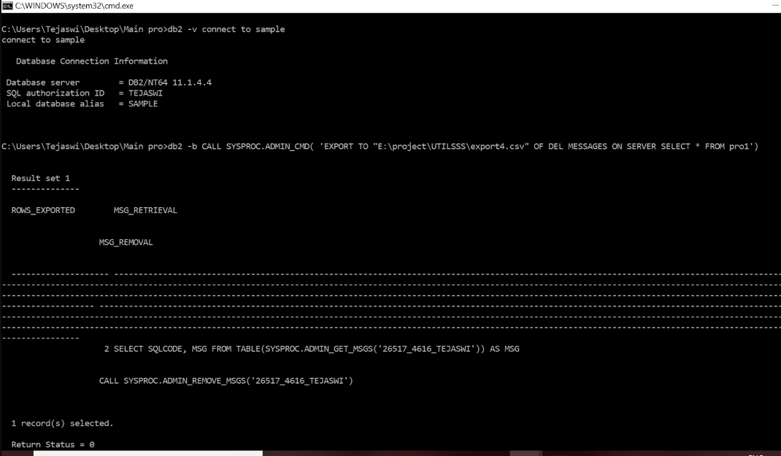

cd C:\Program Files\MongoDB\Server\4.2\bin

mongoimport --db export --collection bt3 --type csv --file E:\project\utilsss\export4.csv --headerline

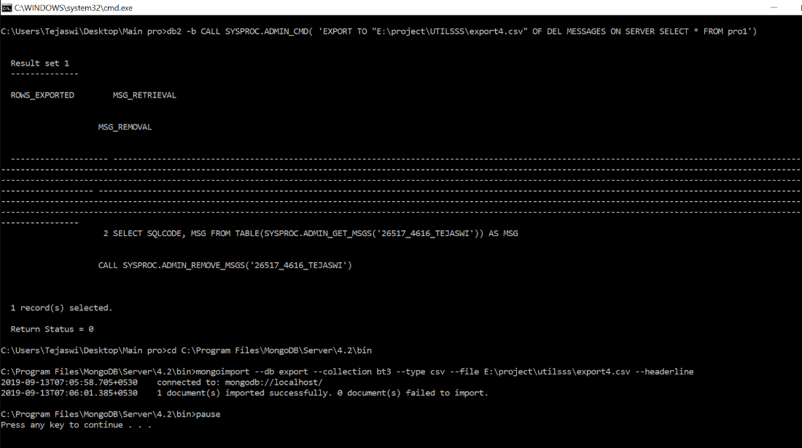

**Testing Phase:**